Marie Francis, MA, Licensed Professional Counselor Licensed Clinical Addictions Specialist
“Once upon a time…” is the beginning of many stories. The Maycis Group believes each of us has a personal story that is worthy of an audience. If you are considering individual therapy, or marriage counseling, you have a story to tell and we are here to listen to it.
The Maycis Group, PLLC
3308 Durham Chapel Hill Blvd.
Suite 131
Durham, NC 27707
4016 Barrett Dr.
Suite 104
Raleigh, NC 27609
Phone: (919) 914-4180
Email: marie@themaycisgroup.com

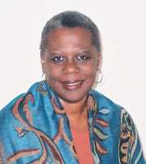

Specialized Services
- Addiction & Substance Abuse
- Therapy for Depression and Anxiety
- Relationship Enhancement
- Religious Recovery
- Parenting Support
- Stress Management
In a comfortable and private atmosphere, I offer a highly personalized approach tailored to each client’s individual needs to help attain the personal growth they’re striving for.

Visit www.themaycisgroup.com for more information.
Find your serenity

